Challenges Task:

1. Launch one instance ec2 and install Jenkins.
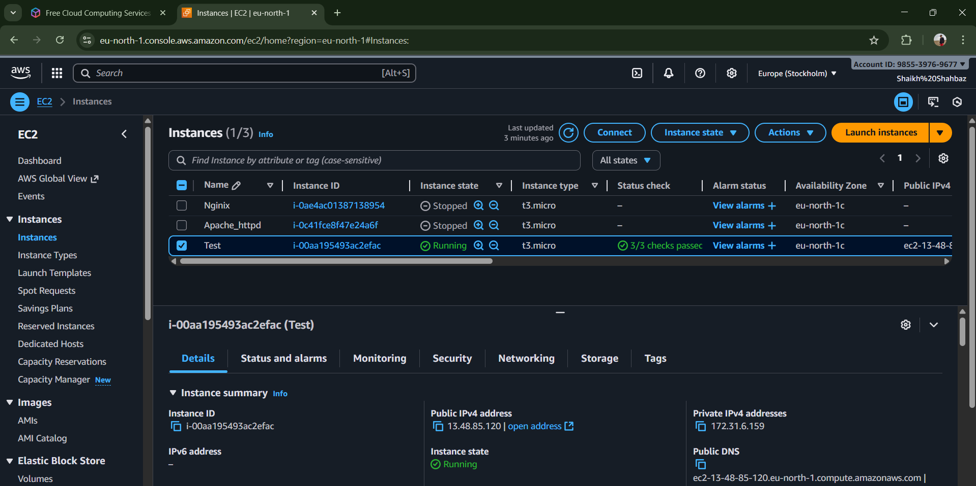
# Ec2 instance with the name Test has been launched and is running.
# Now with the public ipv4 address with the key.pem in downloads I have opened git bash terminal and run the following command :
# ssh -i linux.pem ec2-user@2-13-48-85-120 -
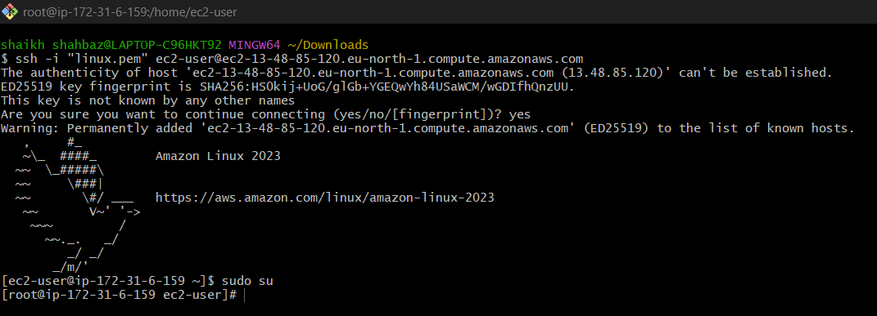

Install Jenkins :
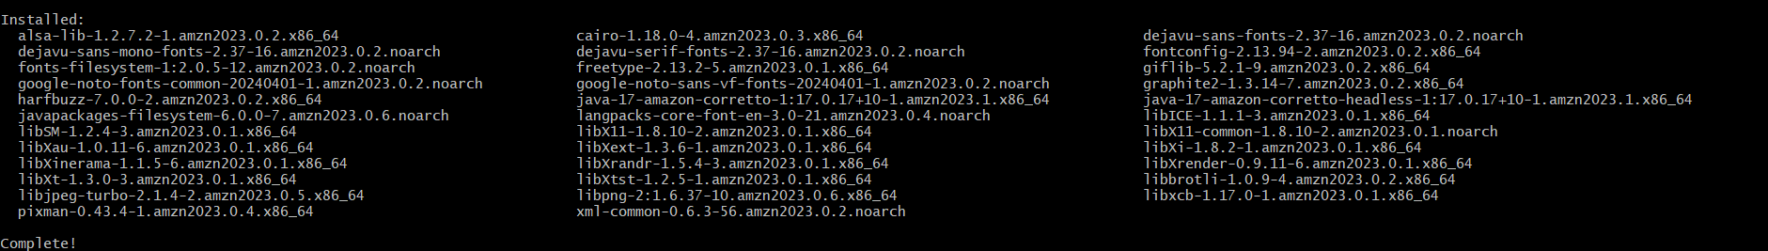
Installed java yum install java-amazon-corretto -y
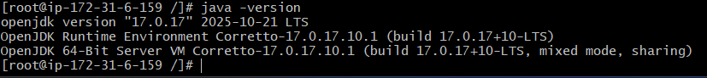
To check the java version java -version
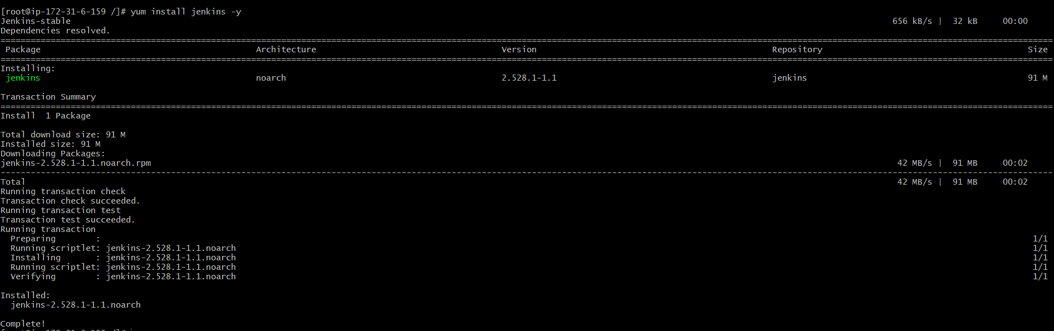
To install Jenkins yum install Jenkins -y
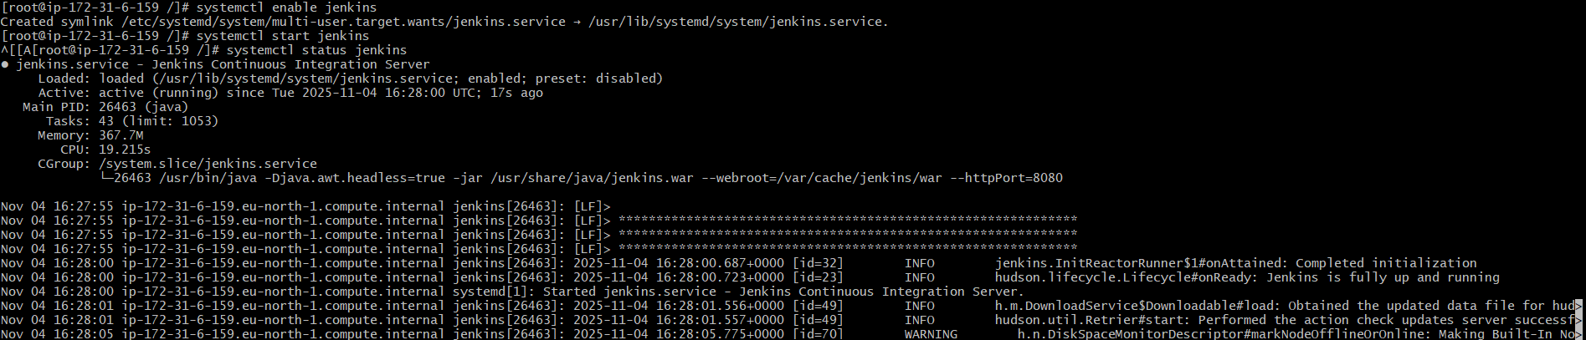
Enabled and start jenkins service
systemctl enable Jenkins
systemctl start Jenkins
systemctl status Jenkins

2. Setup Apache Tomcat on ubuntu virtual machine.

First we need to install jdk inorder to install apache tomcat
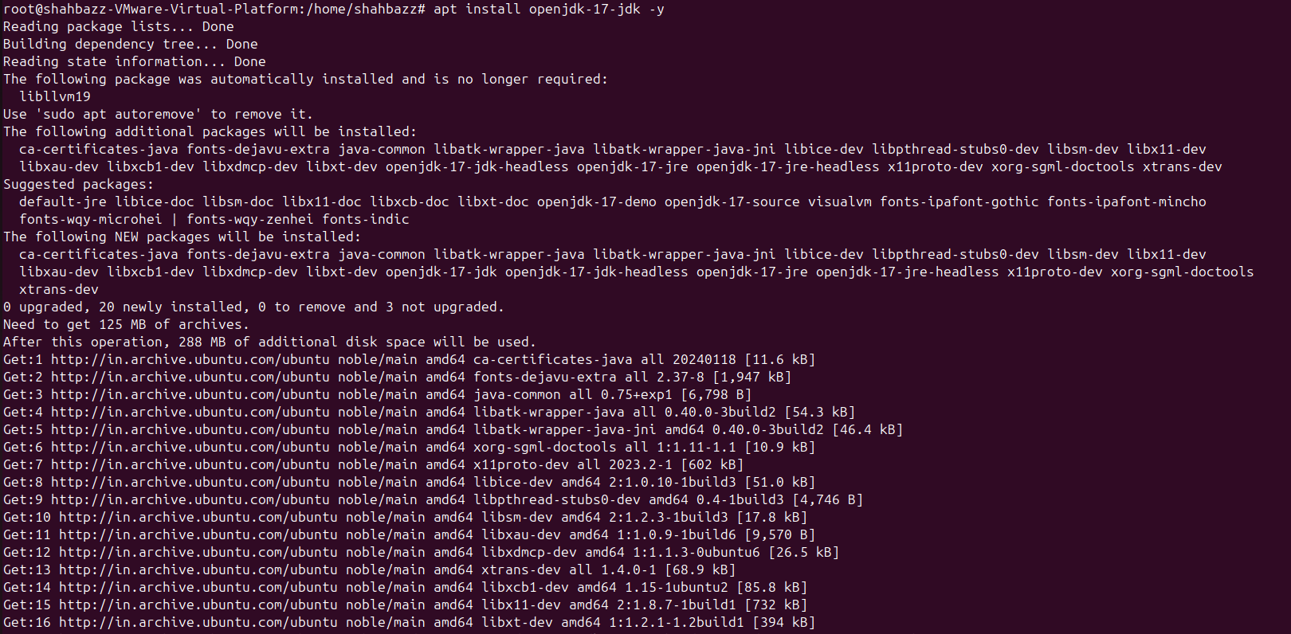
apt install openjdk-17-jdk -y
To check java version java -version
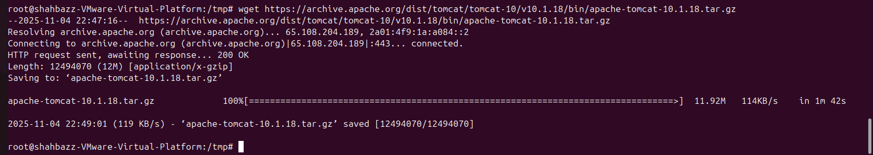
cd /tmp
wget https://archive.apache.org/dist/tomcat/tomcat-10/v10.1.18/bin/apache-tomcat-10.1.18.tar.gz
to extract this file : tar -xvzf apache-tomcat-10.1.18 /opt/tomcat
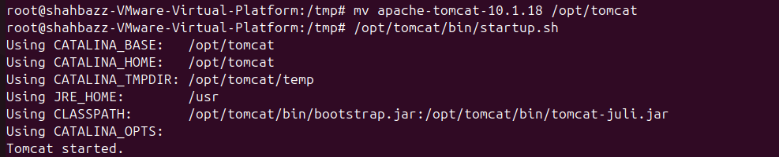
to start apache tomcat : /opt/tomcat/bin/startup.sh
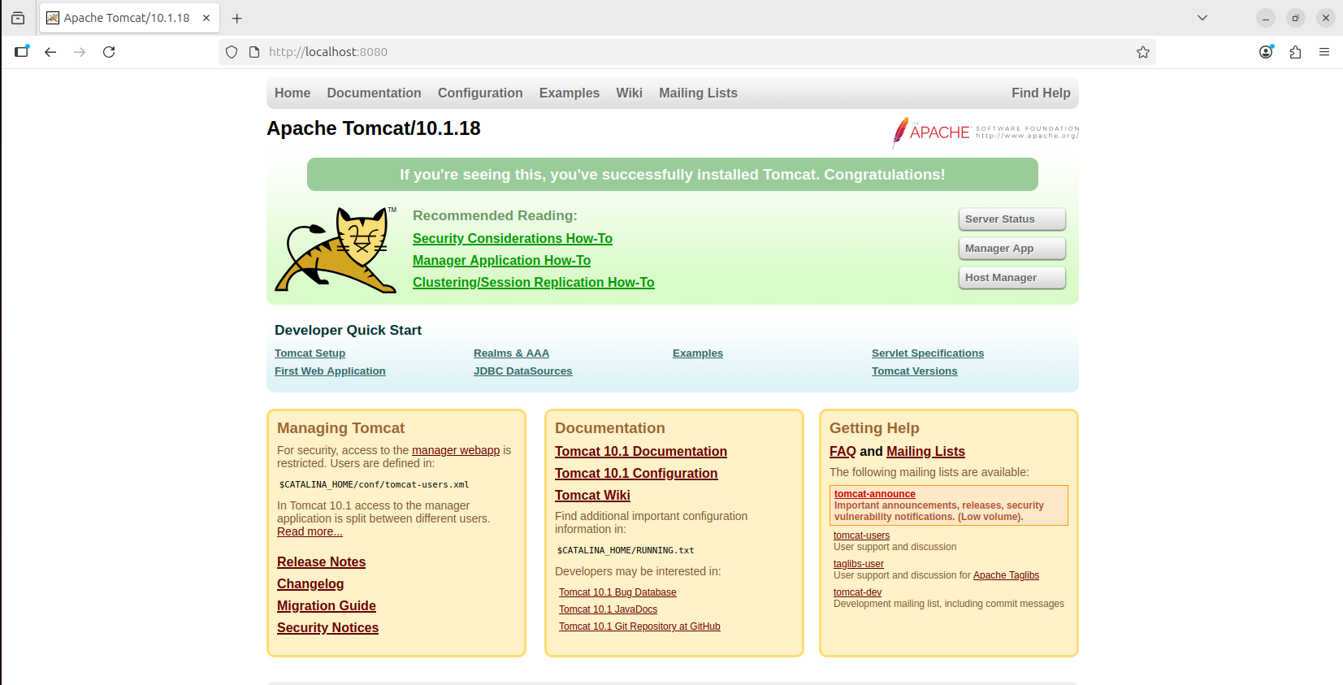
Search in ubuntu browser : http://localhot:8080

3. Setup Docker Desktop on your local windows.

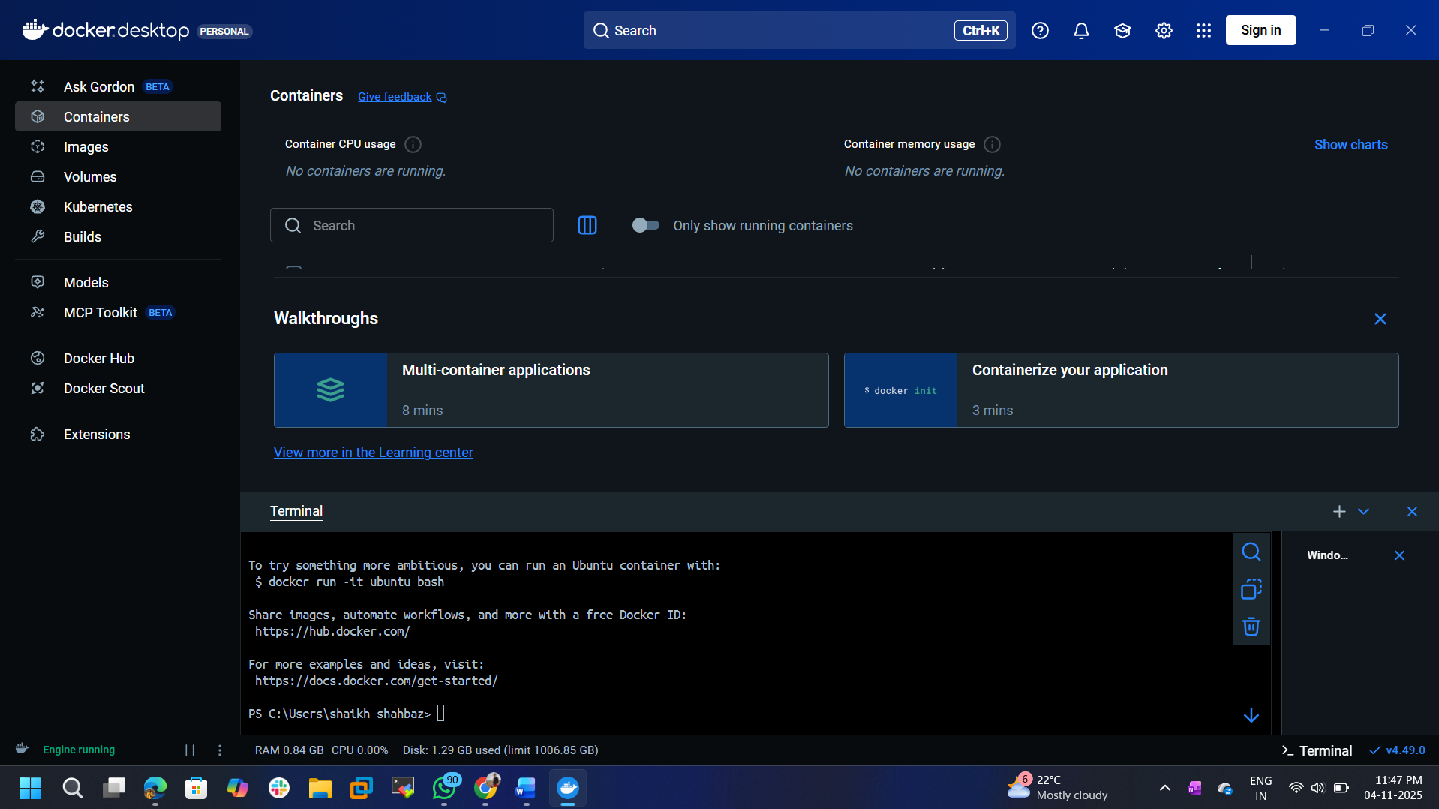
Downloaded and installed in my windows desktop.

